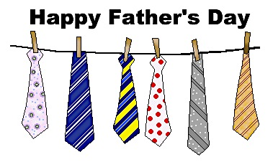

WELCOME TO THE BLACK OLIVE RESTAURANT FATHER’S DAY DINNER SPECIALS

DESSERT OF THE DAY:

**XANGO.……………….$8.99**

***(TWO TIERS OF FRIED CHEESE CAKE, TWO SCOOPS OF ICECREAM, FRESH BANANAS AND STRAWBERRIES, CINNAMON SUGARED PITA POINTS, AND TOPPED WITH DRIZZLED CARAMEL AND CHOCOLATE)***

SOUP OF THE DAY APPETIZER OF THE DAY

***CHICKEN PASTINA FRIED CALAMARI………….$8.99***

***BEEF ESCAROLE***

1. COWBOY PRIME RIB …..…………..…..………………………$25.99

WITH CARAMELIZED FRIED ONIONS, GARLIC MASHED POTATOES AND ONE VEGETABLE

1. FATHER’S DAY SEAFOOD SCAMPI………………….…….....$25.99

SHRIMP, SCALLOPS, CRABMEAT, LITTLE NECK CLAMS, MUSSELS AND LOBSTER TAIL IN A GARLIC LEMOM SCAMPI SAUCE SERVED OVER LINGUINE

1. PASTA BELLA LUNA……………..…...………………...….,..…$19.99

RIGATONI, PENNE, GNOCCHI, CHEESE RAVIOLI AND CHEESE MANICOTTI IN A CRABMEAT BLUSH SAUCE

1. MARYLAND STUFFED SALMON……………………..…….…$21.99

STUFFED WITH CRABMEAT AND PETITE SHRIMP SERVED WITH TWO VEGETABLES

1. GRILLED CHICKEN MADEIRA………………………………..$16.99

TOPPED WITH ASPARAGUS, MELTED MOZZARELLA CHEESE AND PORTABELLO MUSHROOM IN A MADEIRA WINE SAUCE SERVED WITH MASHED POTATOES

1. FATHER’S DAY SURF AND TURF…..…...………….…….......$28.99

10 OZ FILET MINGON AND (1) STUFFED LOBSTER TAIL WITH CRABMEAT STUFFING SERVED WITH A SIDE OF TWO VEGETABLES OF YOUR CHOICE

VEGETABLES OF THE DAY

MASHED POTATO, BAKED POTATO, FRENCH FRIES, COLE SLAW, APPLE SAUCE, COTTAGE CHEESE, PICKLED BEETS, STEAMED RICE, POTATO SALAD, MEDLEY

OR ZUCCHINI STICKS

THANK YOU FOR DINING WITH US

HAPPY FATHER’S DAY